Test Case: tc001_SPX_Dev5_Crear_Solicitud_Articulo_Almacen
Step 1 - Enter username and password and click to button Enter : Credentials Entered
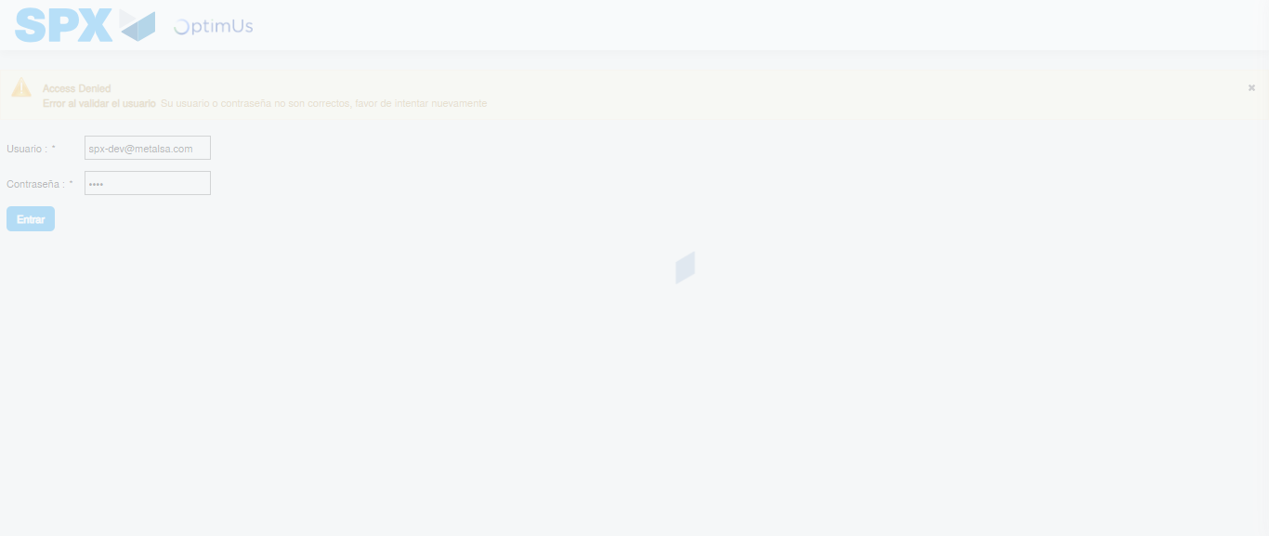Image file-name: QC_Testing-tc001_SPX_Dev5_Crear_Solicitud_Articulo_Almacen-1787933463586

Step 2 - Select to UEN and Access to Request for a New Inventory Item : UEN Correctly selected and Correct access
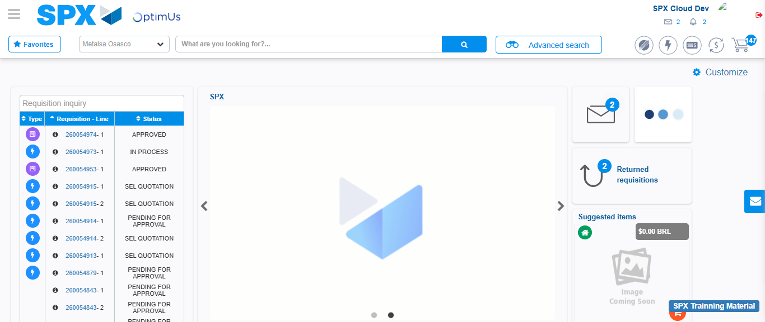Image file-name: QC_Testing-tc001_SPX_Dev5_Crear_Solicitud_Articulo_Almacen-1787933490642

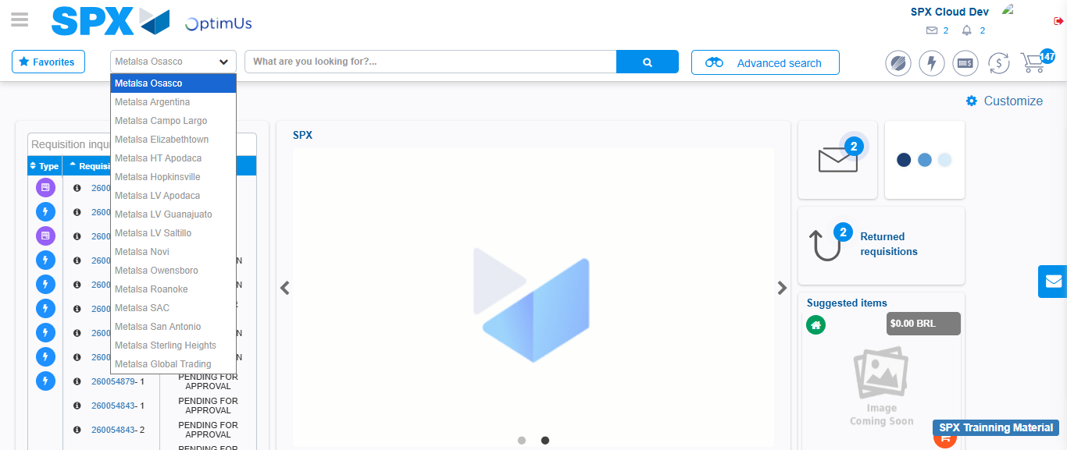Image file-name: QC_Testing-tc001_SPX_Dev5_Crear_Solicitud_Articulo_Almacen-1787933491328

Image file-name: QC_Testing-tc001_SPX_Dev5_Crear_Solicitud_Articulo_Almacen-1787933515819

Step 3 - Select options first section : Options seleted correctly
Image file-name: QC_Testing-tc001_SPX_Dev5_Crear_Solicitud_Articulo_Almacen-1787933516053

Image file-name: QC_Testing-tc001_SPX_Dev5_Crear_Solicitud_Articulo_Almacen-1787933516202

Step 4 - Select options at Screen: Options seleted correctly
Image file-name: QC_Testing-tc001_SPX_Dev5_Crear_Solicitud_Articulo_Almacen-1787933516053

Image file-name: QC_Testing-tc001_SPX_Dev5_Crear_Solicitud_Articulo_Almacen-1787933516202

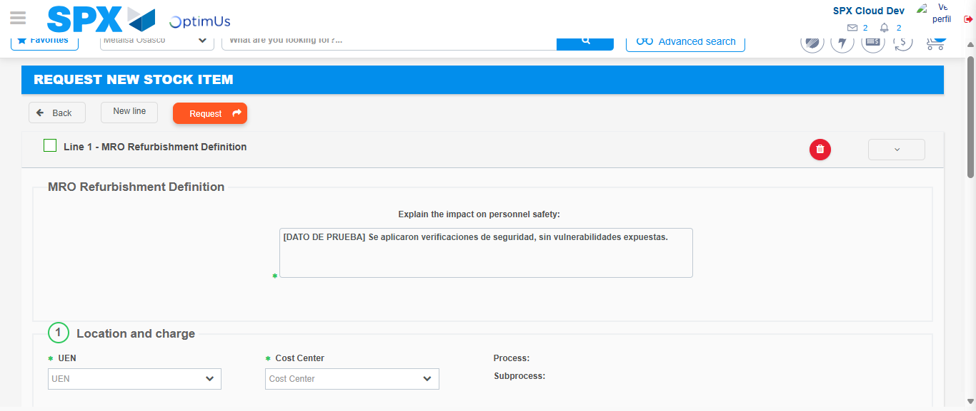Image file-name: QC_Testing-tc001_SPX_Dev5_Crear_Solicitud_Articulo_Almacen-1787933522919

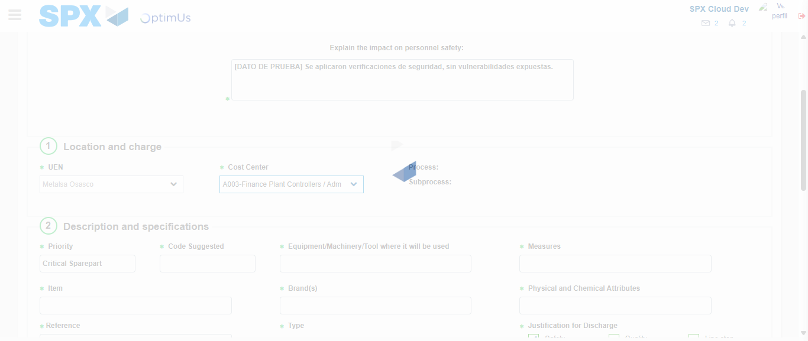Image file-name: QC_Testing-tc001_SPX_Dev5_Crear_Solicitud_Articulo_Almacen-1787933526037

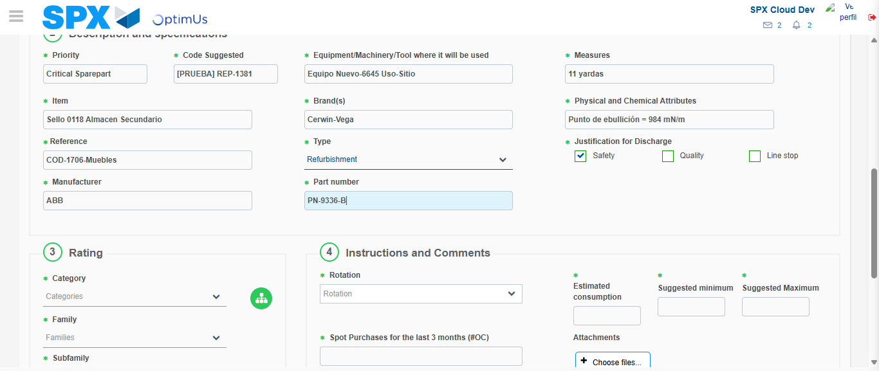Image file-name: QC_Testing-tc001_SPX_Dev5_Crear_Solicitud_Articulo_Almacen-1787933528273

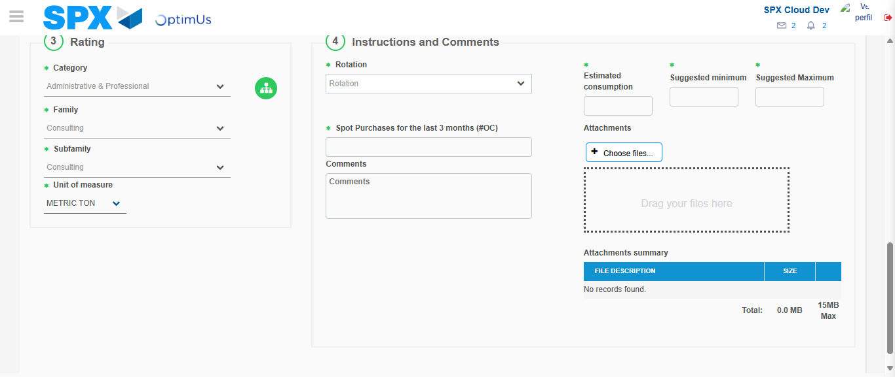Image file-name: QC_Testing-tc001_SPX_Dev5_Crear_Solicitud_Articulo_Almacen-1787933533567

Step 5 - Request New Item : Request Accepted
Image file-name: QC_Testing-tc001_SPX_Dev5_Crear_Solicitud_Articulo_Almacen-1787933490642

Image file-name: QC_Testing-tc001_SPX_Dev5_Crear_Solicitud_Articulo_Almacen-1787933491328

Image file-name: QC_Testing-tc001_SPX_Dev5_Crear_Solicitud_Articulo_Almacen-1787933515819

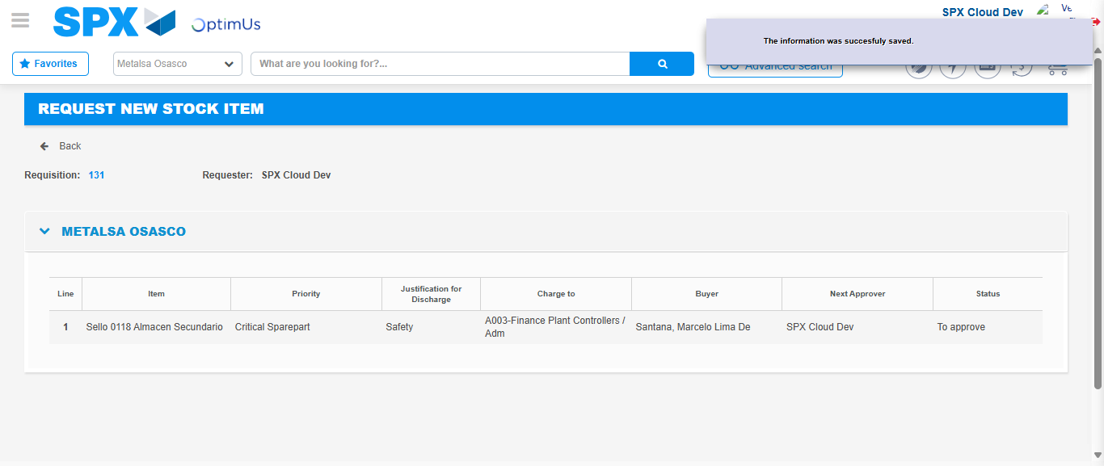Image file-name: QC_Testing-tc001_SPX_Dev5_Crear_Solicitud_Articulo_Almacen-1787933541150

Image file-name: QC_Testing-tc001_SPX_Dev5_Crear_Solicitud_Articulo_Almacen-1787933541307

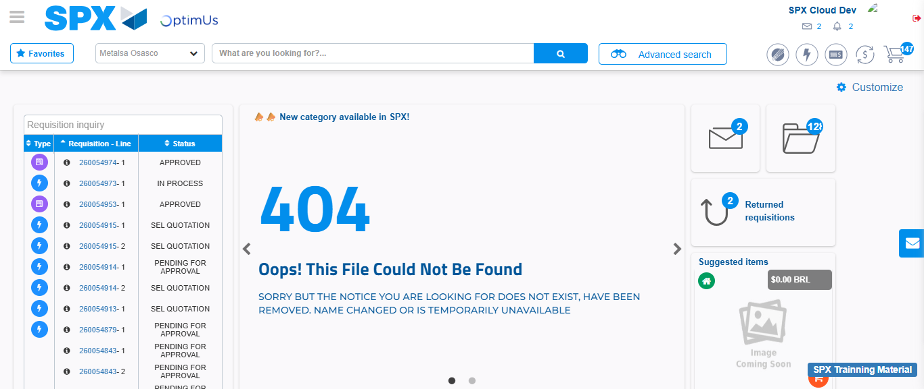Image file-name: QC_Testing-tc001_SPX_Dev5_Crear_Solicitud_Articulo_Almacen-1787933562704

Step 7 - Return to Main Page SPX : Return to Main Page SPX
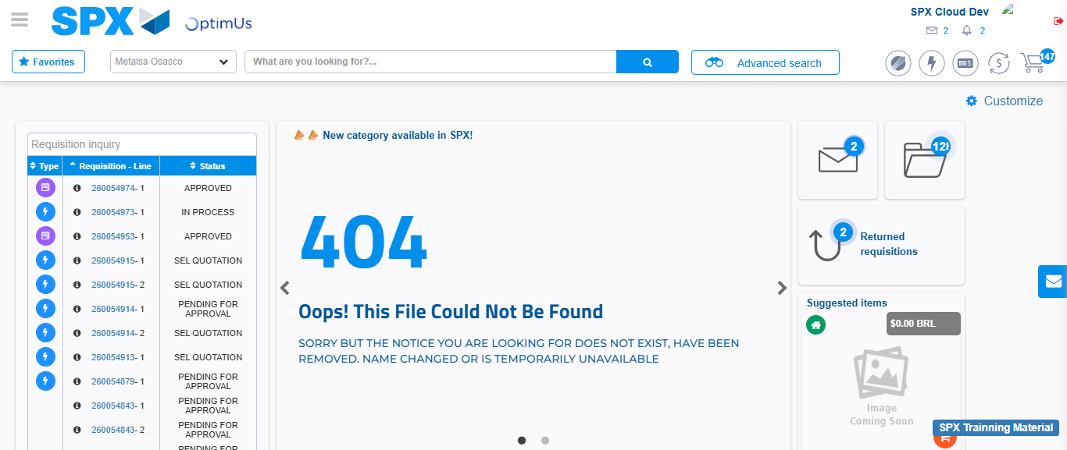Image file-name: QC_Testing-tc001_SPX_Dev5_Crear_Solicitud_Articulo_Almacen-1787933563110

